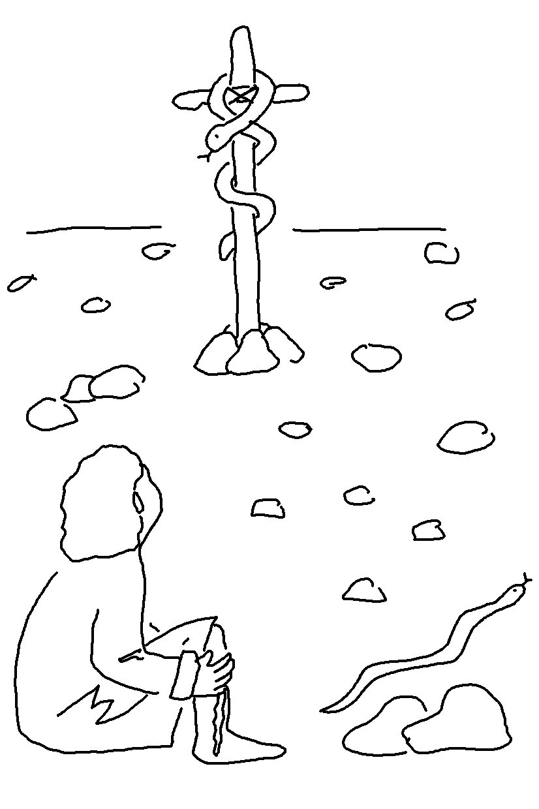
In John 12:32_{NLT} Jesus said, "And when I am
Lifted up from the
earth, I will draw everyone to myself."

